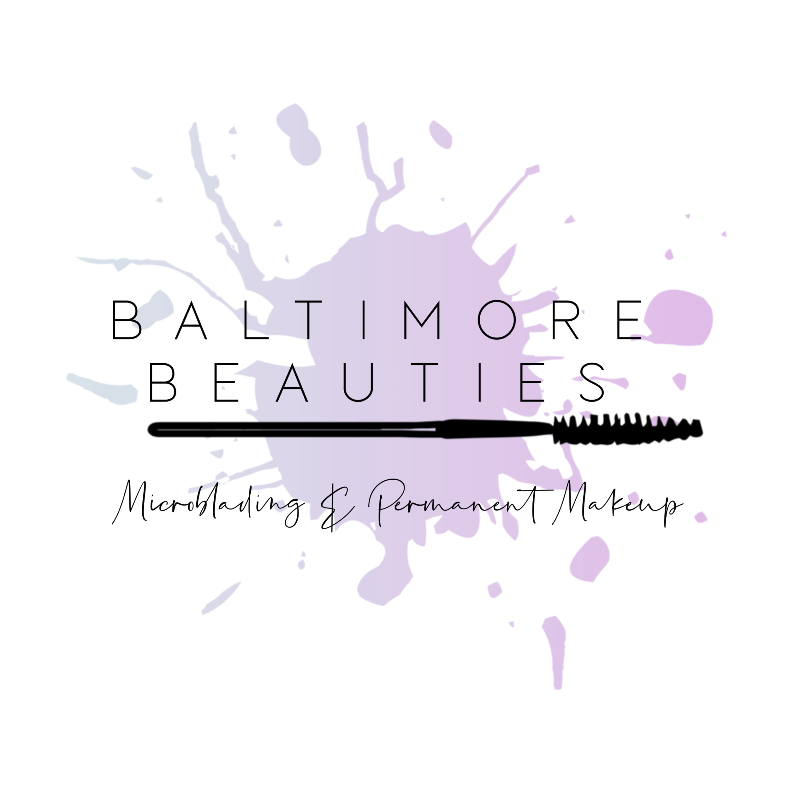

Thank you for choosing me as your permanent makeup artist! I wanted to take just a few minutes to go over new policies and procedures that will be implemented due to the COVID19 pandemic.

BEFORE YOUR APPOINTMENT

Please fill out and sign all paperwork and send it to me before you arrive for your appointment. No paper copies will be kept at the shop.

Please reschedule your appointment for any of the following reasons:
You have been in contact with someone who has tested positive for COVID19
You have traveled to a “hot spot” area within 14 days of your appointment
If you or anyone in your house has a fever, has tested positive, or have come in contact with someone who tests positive for COVID19
If you think you are getting sick

All transactions are preferred to be cashless. Please make sure the credit card that you booked your appointment with is what you want to pay with. I will charge the card on file AFTER your appointment. If you have to reschedule due to illness, no fees will be charged for having to cancel within 24 hours.

Your temperature will be taken before you enter the studio, and per CDC regulations any temperature above 99.1 will be asked to reschedule.

Please eat and drink before your appointment. No food or drink will be permitted in the studio.

Please come alone to your appointment. Only You and I will be permitted in my studio at one time. Everyone else will be asked to wait in the car.

Please wear a mask to your appointment. You will be required to wear it for the entire appointment. Face masks are hot, dress accordingly. My studio may be on the cooler side because of the PPE, so take that into consideration too.

If the door is locked when you arrive that means I am either still with a client OR disinfecting the space for your appointment. You can sit in your car and I will text you when I am ready for you to come in. I will try my absolute hardest to stay on schedule but your patience is greatly appreciated.

DURING YOUR APPOINTMENT

When you arrive for your appointment I will have a plastic bag where you will put your belongings, and they must remain in the bag until you exit the studio.

The client is then guided to the handwashing station to wash their hands with soap and warm water for 20 seconds and go directly to the procedure area

Customers should wash and or/sanitize their hands before and after handling any papers, documents, pens, surfaces, keyboards, or devices.
Talking should be kept at a minimum because the more we talk the more particulates are expelled during conversation. There is also evidence that nasal breathing will produce less moisture than mouth breathing, and the nasal passage is the first line of defence.

AFTER YOUR APPOINTMENT

Aftercare instructions will be sent digitally, and if you have any questions please don't hesitate to ask.

it is also critical for you to inform me if you exhibit any signs of COVID-19 after the procedure.

if I have been exposed to a client who soon-after develops symptoms, I will follow local mandates which will likely include cancelling all clients for the next 14 days.

